**Grafana Assignment**

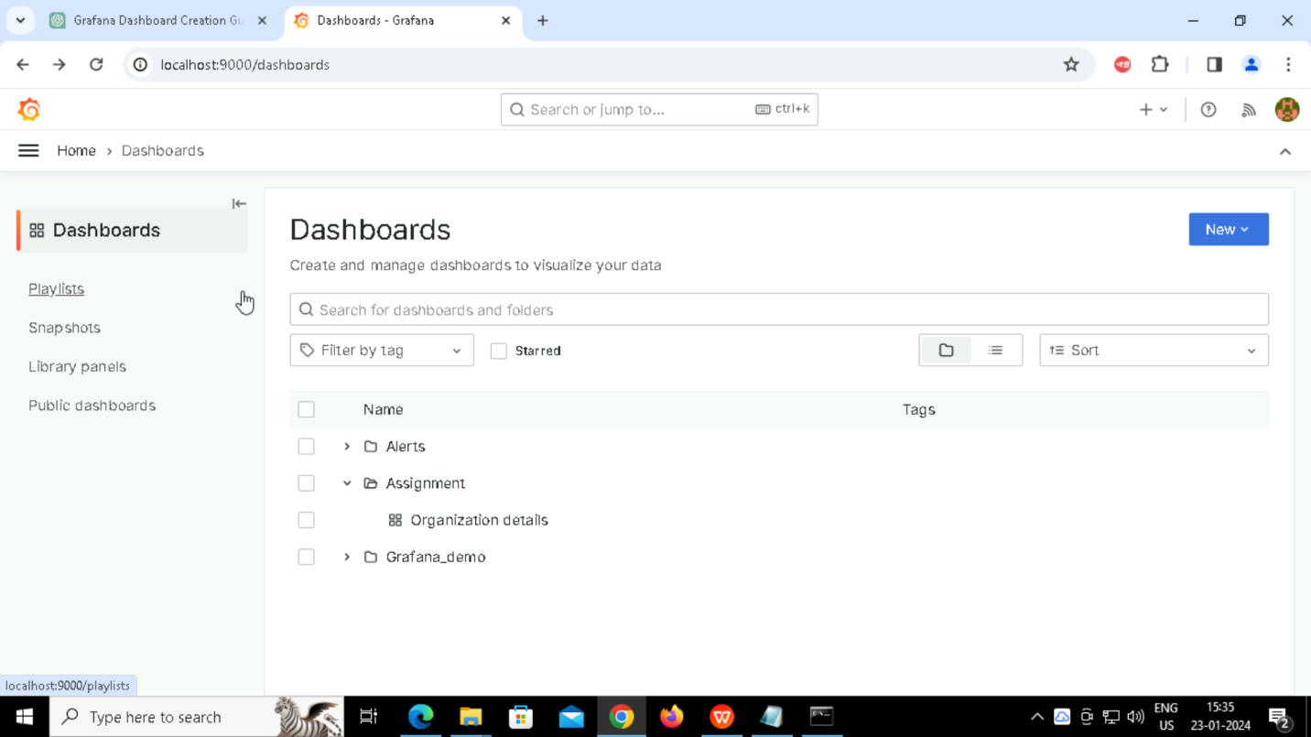

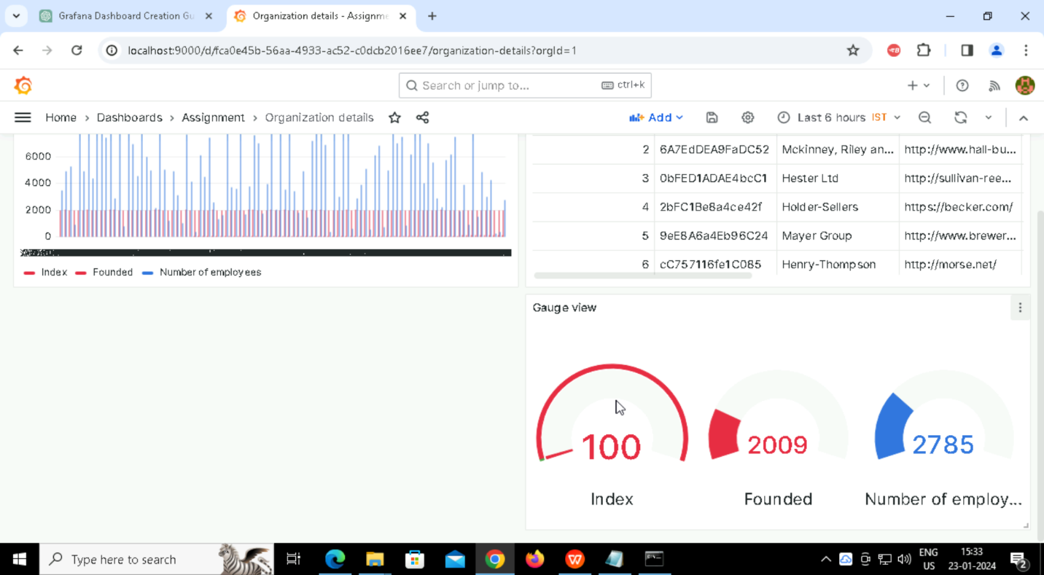

**Panels and Visualization Types:**

1, Time-Series Graph:

Explanation: This panel could display the trend of a particular metric over time, such as the growth of organizations.

Visualization Type: Time-series line graph.

2, Table:

Explanation: A tabular panel showing detailed information about each organization, including various attributes.

Visualization Type: Table.

3, Gauge:

Explanation: This panel might represent a summary metric, like the average size of organizations or any other relevant metric.

Visualization Type: Gauge.

4, Bar Graph

Explanation: Displaying a comparison between different attributes of organizations.

Visualization Type: Bar graph.

Challenges Faced and Solutions:

1, CSV Data Source Configuration:

Challenge: Configuring the CSV data source correctly.

Solution: Carefully follow the documentation and ensure the URL and other settings are accurate. Check for any permission issues with accessing the CSV file.

2, Panel Configuration:

Challenge: Configuring each panel to use the CSV data source and displaying the desired metrics.

Solution: Double-check the data source settings for each panel. Experiment with different query options until the desired data is displayed.

3, Interactivity Implementation:

Challenge: Implementing time range selectors or dropdowns for interactivity.

Solution: Refer to the Grafana documentation on how to add and configure time range selectors. Ensure that each panel is configured to respond to the selected time range.

4, Customizing Visualizations:

Challenge: Adjusting visualizations based on the data in the CSV file.

Solution: Experiment with different visualization settings. Use Grafana's query editor to refine queries and customize visualization options for each panel.